**Ganpat University**

**Faculty of Engineering & Technology**

**Computer Science & Engineering**

**(2CSE204) Basics of Operating System and Shell Scripting**

**Practical 3**

***Name:- Dwij Vatsal Desai***

***Sem:- 2***

***Sub: - BOSS***

***Enrollment No.:- 23162121027***

***Prac:- 3***

***Date:- 27/2/2024***

1. Create following files inside /tmp/yourname directory:

userv1

userv2

userv3

userw1

userw2

userw3

userx1

userx2

usery1

usery2

userz

**Command:-** touch User{v{1,2,3},w{1,2,3},x{1,2},y{1,2},z}

**Image:-**

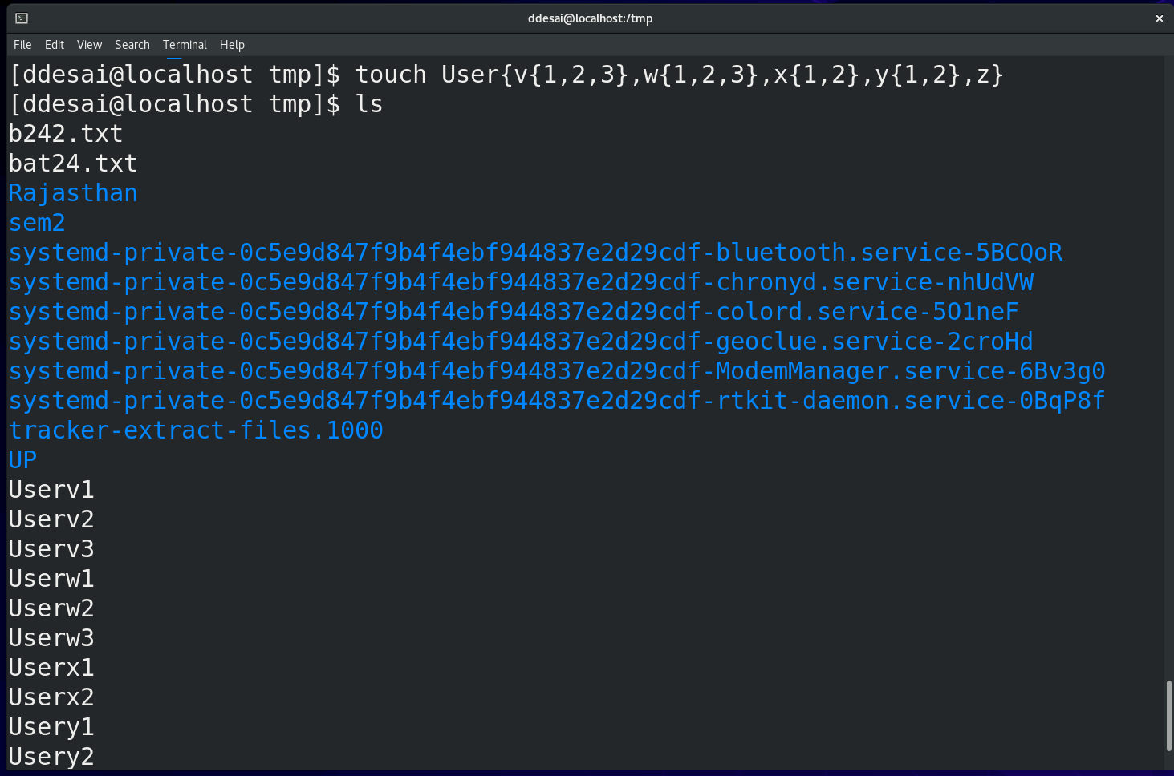  


1. Display the following statements on terminal:
2. Currently logged in user is ***username***

**Command:-** echo "Currently logged in user is $(whoami)"

**Image:-**

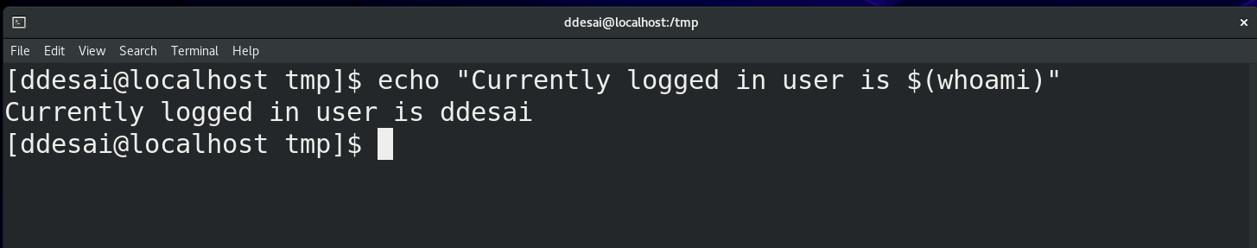

1. Define a variable named *mynumber* which contains your name and display it as: **My enrolment number is *mynumber***

**Command:-** mynumber="Dwij desai"

echo "My enrolment number is ${mynumber}"

mynumber="23162121027"

echo "My enrolment number is ${mynumber}"  
**Image:-**

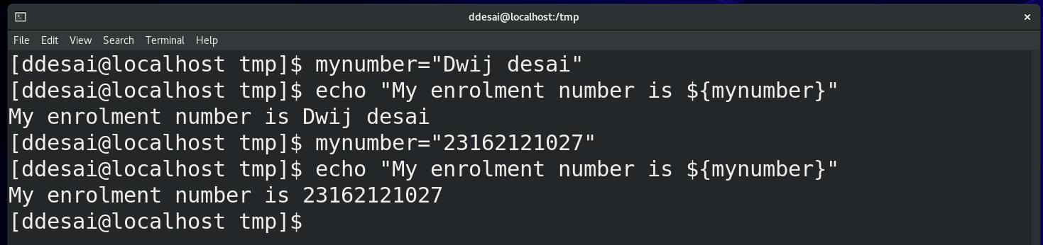

1. Today’s date is ***date_in_yyyy_mm_dd_format***

**Command:-** asked_date=$(date +%F)

echo "Today's Date is ${asked_date}"

**Image:-**

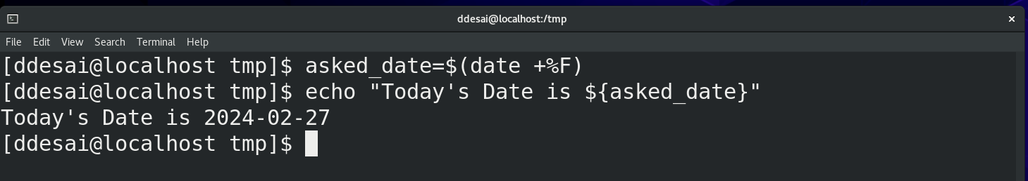

1. Create a soft link of the file /tmp/mydir/boss on student user’s desktop which contains the content “Softlink Example” and verify that the behaviour of soft link is same as a shortcut of a file.

**Command:-** touch original

ln -s /tmp/orignal /tmp/softlink

ls -l /tmp

**Image:-**

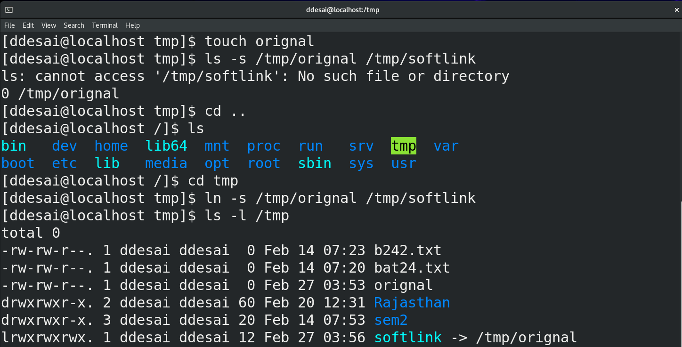

1. Create a hard link to the file /tmp/mydir/boss2  on student user’s desktop which contains the content “Hardlink Example” and verify that the behaviour of hard link is same as a copy of a file.

**Command:-** touch orignal

ln /tmp/orignal /tmp/hardlink

ls -l

**Image:-**

